**PIEP – DeletionPS**

**User Guide**

## VERSIONING AND CONTROL VALIDATION

VERSIONING HISTORY

|  |  |  |  |
| --- | --- | --- | --- |
| Version | AUTHOR | REVISION | Date |
| 1.0 | RCAS (CGI) | Creation | 20/05/2020 |
| 1.1 | RCAS (CGI) | Review prerequisite | 17/08/2020 |
|  |  |  |  |

VALIDATION

|  |  |  |
| --- | --- | --- |
| Version | Name | Date |
| 1.0 |  |  |
|  |  |  |

## DOCUMENT CONTENT

1. VERSIONING AND CONTROL VALIDATION 2

2. DOCUMENT CONTENT 3

3. SCRIPT DESCRIPTION 4

3.1 Objective 4

3.2 Prerequisite 4

4. USER GUIDE 5

4.1 Prepare the input file 5

4.2 Configure 01-DeletionPS.bat 5

4.3 Run DeletionPS 6

## SCRIPT DESCRIPTION

### Objective

**The purpose of DeletionPS is to delete the tags on a PI data archive server**.

The user have to provide the server name and the list of tags to delete.

### Prerequisite

* Microsoft Powershell (1.0 or later).
* PI SMT 2018 or later.

## USER GUIDE

Copy the folder DeletionPS in your local machine/server.

### 4.1 Prepare the input file

Get the list of the tags you want to delete. Copy the list on the folder “.\input\Points.txt”, one tag per line. Example :

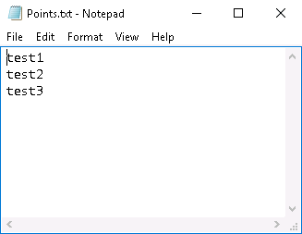

### 4.2 Configure 01-DeletionPS.bat

Edit the file “.\script\01-DeletionPS.bat”.

*cd ..*

*powershell.exe -file .\DeletionPS.ps1 -piServerHost "PI-CENTER-HQ"*

Modify the following parameters :

* **PIServerHost** : Name of the PI Server to delete tags (exemple : PI-CENTER-HQ)

Then save the modifications and close the file.

### 4.3 Run DeletionPS

**Run the script 01-DeletionPS.bat** (**do not** run it as administrator).

You should have the following window opened. Presse <Enter> to valid the deletion.

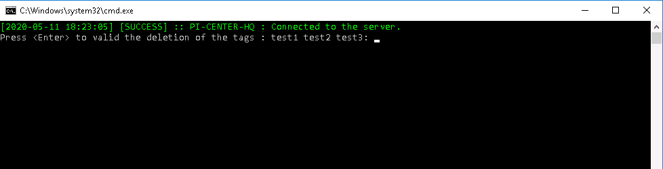

Then let the application delete all archived event and tags structure. If some tags does not exist, the application will mention it (example below with tag <test2> which does not exist) :

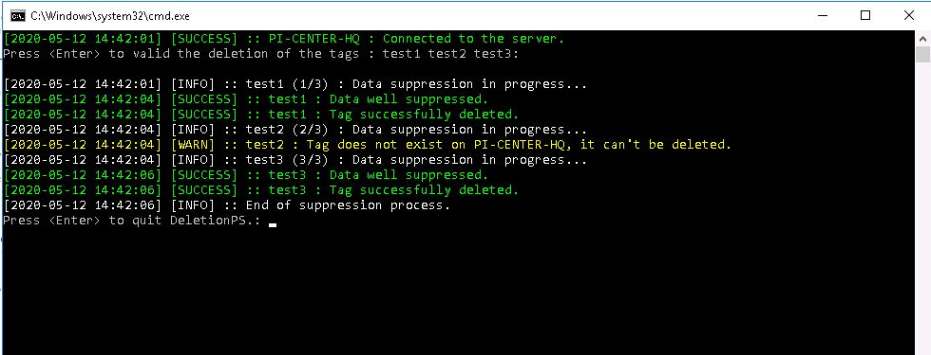

Press <Enter> to quit the application.